**t.** +420 123 456 789

**e.** filip@mampohovor.cz

**b.** Prague

Filip Životopisný

*Construction Technician*

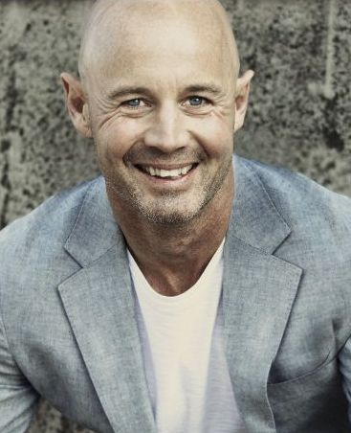

*2007*

ČVUT Prague, recognition of foreign education

*2005*

Diploma: Project activity high current and low current

Institute of Electrical Engineering, Germany

Název firmy, s.r.o.  *2020 – current*

**Construction Technician**

Providing professional advisory, planning, subsequent implementation + installation.

Název firmy, s.r.o. *2013 – 2019*

**Construction Technician**

Implemented projects: Vysočanská metro station, Innovation of XY technology, completion of the Harfa center, Palmovka III Park, construction adjustments of Air Traffic Directorate near Prague.

**Construction Technician in the Extreme Light Infrastructure** **Project**

(ELI) is part of a European plan to build a new generation of large research facilities selected by the European Strategy Forum for Research Infrastructures (ESFRI).

Název firmy, s.r.o. *2012 – 2013*

**External Technical Advisor and Quality Manager**

Reference reconstruction building Residence of Ambassador in Prague

Název firmy, s.r.o *2006 – 2011*

**Quantity Surveyor, Technician and Construction Supervisor**

Název firmy, s.r.o. *2001 – 2003*

**Control Unit Technician for Emergency Lighting Systems, Trainer**

AutoCAD, Microsoft Access, basics of Photo-Shop, Turbo Pascal and Corel Draw, design of intelligent systems for emergency lights

Education

Professional Experience

**Gradua-Cegos, s.r.o.**

Project Management I-Tools and methods of project planning

How to successfully manage a project team

Honeywell **Esser Security and Fire** workshop

**System EPS, Siemens – Sinteso**

**System Plena Voice Alarm, Bosch**

German C2

Czech C1

English B2

Reading books, music, recreational sport (swimming, biking)

Courses

Languages

Hobbies

Skills