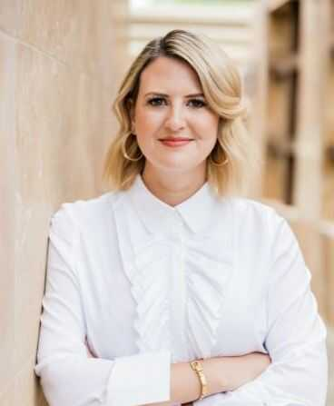

MARTINA

**POHOVOROVÁ**



+420 123 456 789

martina@mampohovor.cz

Prague

*Desire and willingness to travel, and remote cooperation*



BUSINESS DEVELOPMENT, GLOBAL SALES, MARKETING, KAM

PROFILE

I gained experience mainly in managerial positions in various areas such as **business development, key account management, marketing, brand management, project and strategic management, and setting and implementation of processes.**

Due to my experience, I can offer functional and competence overlap, which allows me to perceive problems more comprehensively and come up with a fast yet effective solution. I like to be a part of creating new things - I can generate new ideas. I am able to work on multiple projects at the same time.

I am focused on results, quality, and strong business relationships. My enthusiasm can stir everyone around me.

EDUCATION

CAP, CPE business English and Italian bachelor’s exam

Grammar School

Brno

1993 - 1997

SKILLS

Leadership

Leadership of international teams

Project & brand management

Premium brand marketing

Crisis management

Strong analytical skills and logical thinking

Critical thinking

Performance and efficiency

Agile approach

MY ASSET TO YOUR COMPANY

Excellent representation, negotiation, and language skills.

Experience with strategic and project management, and team leadership.

Proactive solution of potential risks and problems.

Experience in the international field and knowledge of foreign markets.

I respect functional procedures; I change non-functional processes and I can find simple solutions to even a complex problem.

I have the ability to build and establish long-term business relationships.

WORK EXPERIENCE

Název firmy s.r.o. I 10/2018 - current

**Account Director**

*Overall responsibility for business development of our brands for the EMEA region.*

* Implementation of long-term strategies to strengthen the brand and develop new business opportunities.
* Key role in the global environment (leading of project managers and developers).
* Implementation of long-term strategies to increase operational efficiency and business consistency, including sales practices, corporate business goals, and branding.
* Responsibility for P&L and responsibility for the assigned team.

*I have developed a unique concept with a subsequent successful implementation in more than 50 countries.*

WORK EXPERIENCE

Název firmy s.r.o. I 2017 - 2018

**Sales & Marketing Director**

*Supplier of luxury floors and furniture for B2B and B2C international clients.*

* Full responsibility for all modern sales channels.
* Key role in the global environment (leading of project managers).
* Leading a team of sales managers.
* Achieving accurate sales estimates, full responsibility for corporate P&L.
* HR business partner - setting up a recruitment strategy.
* Team performance management and talent development.
* Ensuring high employee commitment and managing a healthy corporate structure.

Název firmy s.r.o. I 2013 - 2017

**Sales & Marketing Manager**

* Creating business strategies and business plans for individual markets.
* Leading of assigned team (3-5 people).
* Setting KPIs + responsibility for the remuneration system.

Název firmy s.r.o. I 2012 - 2013

**PR Consultant & Business Development Manager**

* Building a new business development strategy.
* Communication with the media.

Název firmy s.r.o. I 2011 - 2012

**PR consultant for the financial and political sector**

**Private English and Italian teacher** I 2001 - 2011

Working in a multicultural environment

Positive approach

Quick adaptation to changes

Clear and straightforward communication

Qualification development

Load management

LANGUAGES

Czech C2 native speaker

English C2

Italian C2

Spanish B2

OTHER

MS Office

SAP, M3 ERP

Driver's license group B

Willingness to travel

Possibility of remote cooperation

HOBBIES

Architecture

Design

Marketing

Current events

Travel anywhere in the world