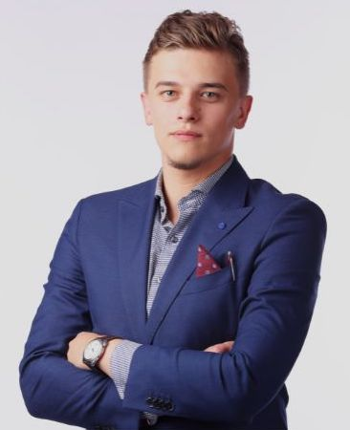

Tomáš POHOVORNÝ

International trade, logistics, freight forwarding, business development

PROFILE

I gained experience mainly in managerial positions in various areas such as: international trade, logistics, freight forwarding, business development, and strategic management.

My enthusiasm can stir everyone around me. I can see opportunities where others see obstacles.

CONTACT

+420 123 456 789

tomas@mampohovor.cz

[Tomáš](https://www.linkedin.com/in/adam-smýkal/) Pohovorný

SKILLS

Leadership

International business

Strategic planning

Business intuition

Entrepreneurial thinking

Process optimization

Analytical and logical thinking

Positive and agile approach

Critical thinking

Negotiation skills

Key account management

Crisis management

Business development

Czech C2 native speaker

English C1

German B1

Willingness to travel





WORK EXPERIENCE

Název firmy s.r.o.

**Country Manager Air&Sea Czech Republic and Slovakia** *9/2019 - present*

* Management of Air&Sea transport division.
* Ensuring smooth running at all levels (sales, HR, project management, product development, marketing, IT).
* Defining and implementing business strategy, preparing business plans, setting targets and KPIs.
* Key leadership role in a global environment.
* Team performance management and talent development.
* Ensuring high employee commitment and a healthy corporate culture.
* Full responsibility for P&L.

**Country Manager Air&Sea Czech Republic** *2014 - 2019*

* Implementing long-term strategies to optimize operational efficiency and business consistency.
* Setting business goals and strengthening the brand in the market.

Název firmy s.r.o.

**Depot Manager** *2013 - 2014*

* Responsible for opening a new branch in Ostrava, offering a wide range of transport and logistics services for automotive, hi-tech, industrial, and other sectors.
* Team building, implementation of company standards and HSEQ principles.
* Creating a business plan and setting goals.

Název firmy s.r.o.

**Branch Manager Air&Sea Ostrava** *2012 - 2013*

**Sales representative** *2009 - 2012*